Collections in Java

* The **Collection in Java** is a framework that provides an architecture to store and manipulate the **group of objects**.
* Bahut sare objects ko single word me hum collection kahege.and usse hum kisi ek variable me store karte hai and ussi veriable ki help se hum uss object ko iterate karege
* Any group of individual objects which are represented as a single unit is known as the collection
* It is the single “entity or object” which can store multiple data
* In Java, a separate framework named the “Collection Framework” has been defined in JDK 1.2 which holds all the collection classes and interface in it.
* The Collection interface (**java.util.Collection**) and Map interface (**java.util.Map**) are the two main “root” interfaces of Java collection classes.

# Data Structure

* It is the way by which we can store the data in the efficient way
* Data to store karne me ya iterate karne me kafi kam time lage and kafi kam space me data ko systemized tarike se store kar ske
* Data strucure two type ka hota hai 1) primitive data tructure 2) non primitive data structure
* Non primitive data ke two type hota hai 1)Linear DS 2) Non linear DS
* Eg: of primitive DS :- boolean,char,byte,short,int,long,float,double
* Eg of Linear DS:- string, array,List set arrayList,LinkList HashMap
* Eg of Non Linear DS: Graph ,Tree

# Different between Array and collection

* Array ke under primitive and non primitive dono type ka data store karva skte hai
* Collections ke under sirf or sirf non primitive data ko store karva skte hai
* Collection ke ender jo bhi store hota hai voh as object ki tarah behave karta hai
* AaryList ab = new ArrayList();

Ab.add(10); -> yaha 10 as a object hai and voh integer ki tarah behave karta hai n ki int ki tarah

* Array store only homogeneous type of data
* Collections store herogeneous type of data also
* Array Size is fixed at run time we can not change it
* Collections size can be decrease or increase at run time
* Arrays are inbuilt feature of java So we have to develop algorithums.Array me hum khud se method banate hai based on the need
* Collections framework is an API which provides predefined classes , interface ,and methods
* Collections ke predefined methods ka use karke hum apna kaam kar skte hai but array me aisa nahi hota hai

# JAVA FRAMEWORK

* **Java Framework** is a collection of predefined classes and functions.
* Framework are the bodies that contains the pre-written codes (classes and functions) in which we can add our code to overcome the problem.
* Yeh ek set of classes and interface jo hume ready made architecture provide karta hai

# Collection FRAMEWORK

* Group of objects ko store and manipulate karne ke liye ek architecture ki requirment hoti hai jo hume collection framework api se milta hai
* Collection interface ka introduction java 1.2 me hua tha
* But Vector class java 1.0 se hi hai

# Collection Hierarchy

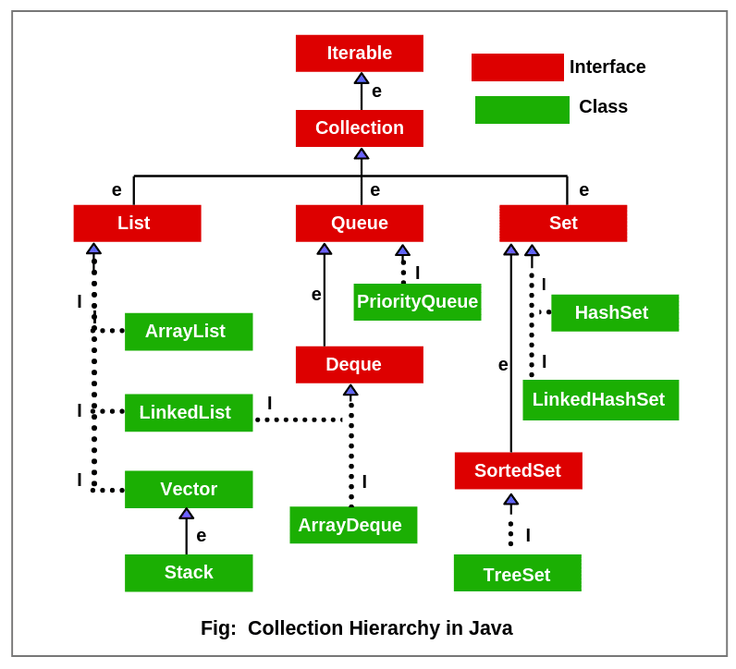

## List Interface

* List interface extends **Collection** and declares the behavior of a collection that stores a sequence of elements.
* Elements can be inserted or accessed by their position in the list, using a zero-based index.
* A list may contain duplicate elements.

## Set Interface

## The **set** is an interface available in the **java.util** package. The **set** interface extends the Collection interface. An unordered collection or list in which duplicates are not allowed is referred to as a **collection interface**.